

**ECEN 5053-003 Homework Assignment**

Course Name: Embedding Sensors and Actuators

Corresponding Module: C3M1

Week Number: 9

Module Name: Pressure Sensors

Submitted by: Poorn Mehta

Homework is worth 100 points.

Part 1: Each question is worth 10 points.

1. Answer the following questions about pressure sensor terminology:

A.1 What is the difference between proof pressure and burst pressure in a pressure sensor?

Answer: By definition, proof pressure is the maximum pressure applied to the sensor before its output sensitivity changes permanently while, burst pressure is the maximum pressure applied to the sensor before it ruptures

and leaks fluid to atmosphere. Therefore, the key difference is that **a sensor can be withstand proof pressure without failing, but it can’t handle burst pressure without having a permanently damaged output.**

A.2 What is a differential pressure sensor?

Answer: The differential pressure sensor measures **the difference of pressure between two fixed point – but none of them are at a fixed pressure.** Unlike gauge or absolute pressure transmitters, differential pressure sensors do not attempt to fix the reference. Importantly an increase in differential can be the result of increasing one of the pressures or decreasing the other [**[1]**](https://www.coulton.com/beginners_guide_to_differential_pressure_transmitters.html).

A.3 What is pressure measurement error?

Answer: The measurement error, or measurement deviation, describes **the shift of the displayed value from the "correct" value**. This "correct" value is an ideal one, which in practice can only be attained with a highly accurate measuring device under reference conditions, such as a primary standard as would be used in calibration. The measurement error is expressed as either an absolute or a relative error. Absolute error is listed in the same units as the measured value, whereas relative error refers to the correct value and remains unit-free [**[2]**](https://campaign.stssensors.com/blog/pressure-measurement-accuracy-non-linearity) .

A.4 What is excitation?

Answer: Active sensors require an external excitation source in order to produce an electrical output signal. It could be either in current or voltage form. Thus, excitation is basically **input energy to supply and operate sensors** [**[3]**](https://www.analog.com/en/analog-dialogue/articles/transducer-sensor-excitation-and-measurement-techniques.html) **.**

A.5 What is the difference between gauge pressure and absolute pressure?

Answer: Absolute pressure is the pressure measurement relative to a perfect vacuum, while gauge pressure is the difference between measured pressure and atmospheric pressure. In other words, **gauge pressure is the pressure only due to the substance under measurement. Absolute pressure is the sum of atmospheric pressure and gauge pressure.**

A.6 What is hysteresis in a pressure measurement? How does it differ mathematically from hysteresis in a voltage measurement?

Answer: The hysteresis error of a pressure sensor is **the maximum difference in output at any measurement value within the sensor's specified range when approaching the point first with increasing and then with decreasing pressure**. The hysteresis error value is normally specified as a positive or negative percentage of the specified pressure range. If a sensor is only used over half of the specified range the hysteresis error is calculated from this value. Also, the hysteresis error is usually expressed as a combination of mechanical and temperature hysteresis [**[4]**](https://appmeas.co.uk/resources/pressure-measurement-notes/what-are-hysteresis-errors/) .

**Mathematically, the hysteresis error value for pressure sensor is a combined value of mechanical and temperature hysteresis – while expressing it relative to the pressure range specified. However, the hysteresis in a voltage measurement is rather absolute measure of values.**

A.7 What is a leakage rate?

Answer: In many instruments/products (such as the medical supplies), it must be confirmed that there is no exchange between the internal atmosphere and the external one. Usually, **if the packaging is not perfect and the product is at different pressure than the atmosphere around it, then the air (or whatever is inside) will leak due to pressure difference – and this could be measure by a sensor kept inside the packaging to monitor the different over time. This will give the drop-in pressure with respect to time – effectively known as leakage rate** [**[5]**](http://blog.servoflo.com/pressure-sensors-for-leak-detection) **.**

A.8 What is the operating pressure range?

Answer: It is the **difference between maximum and minimum pressure limits – between which the sensor is guaranteed to work.** Exceeding those limits may result in undefined behavior of the sensor.

A.9 What is the difference between thick film and thin film production technology?

Answer: Reference – [**[6]**](https://automationforum.co/difference-metal-thin-film-ceramic-thick-film-sensor/)

**Thin Film Production:** The main body and the diaphragm of a metal thin-film sensor are usually made of stainless steel. They can be manufactured with the required material thickness via machining the diaphragm in automatic precision lathes and then grinding, polishing and lapping it. On the side of the diaphragm not in contact with the medium, insulation layers, strain gauges, compensating resistors and conducting paths are applied using a combination of chemical (CVD) and physical (PVD) processes and are photolithographically structured using etching.

These processes are operated under clean room conditions and in special plants, in some parts under vacuum or in an inert atmosphere, in order that structures of high atomic purity can be generated. The resistors and electrical conducting paths manufactured on the sensor are significantly smaller than a micrometer and are thus known as thin-film resistors.

The metal thin-film sensor is very stable as a result of the materials used. In addition, it is resistant to shock and vibration loading as well as dynamic pressure elements. Since the materials used are weldable, the sensor can be welded to the pressure connection − hermetically sealed and without any additional sealing materials. As a result of the ductility of the materials, the sensor has a relatively low overpressure range but a very high burst pressure.

**Thick Film Production:** The main body and the diaphragm of the ceramic thick-film sensor are made of ceramic. Aluminum oxide is widely used due to its stability and good processability. The four strain gauges are applied as a thick-film paste in a screen-printing process onto the side of the diaphragm which will not be in contact with the pressure medium, and then burned in at high temperatures and passivated through a protective coating. No impurities are permitted during the screen-printing and the burn-in processes. Therefore, manufacturing is usually performed in a cleanroom. Only the leading manufacturers are able to operate their plants with the proper segregation in order to avoid any cross-contamination and thus maintain the high process stability.

The ceramic used for the sensor is very corrosion-resistant. However, installation of the sensor into the pressure measuring instrument case requires an additional seal for the pressure connection, which will not be resistant against all media. In addition, the ceramic is brittle and the burst pressure is therefore lower in comparison to a metal thin-film sensor.

B. A platinum wire has Poisson’s ratio ν = 0.39, and resistivity ρ of 1.03 x 10-7 ohm-meter. When the wire is pulled, the lateral strain εL is 0.10 and the resistivity increases to 1.05 x 10-7 ohm-meter. What is the gauge factor of the platinum wire? (Type in a two-decimal number)

Answer: **1.97**

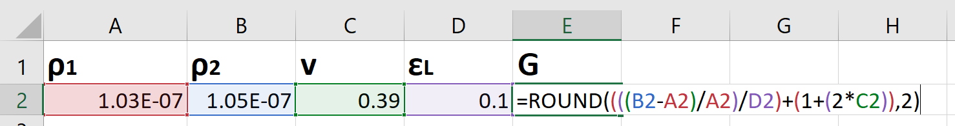

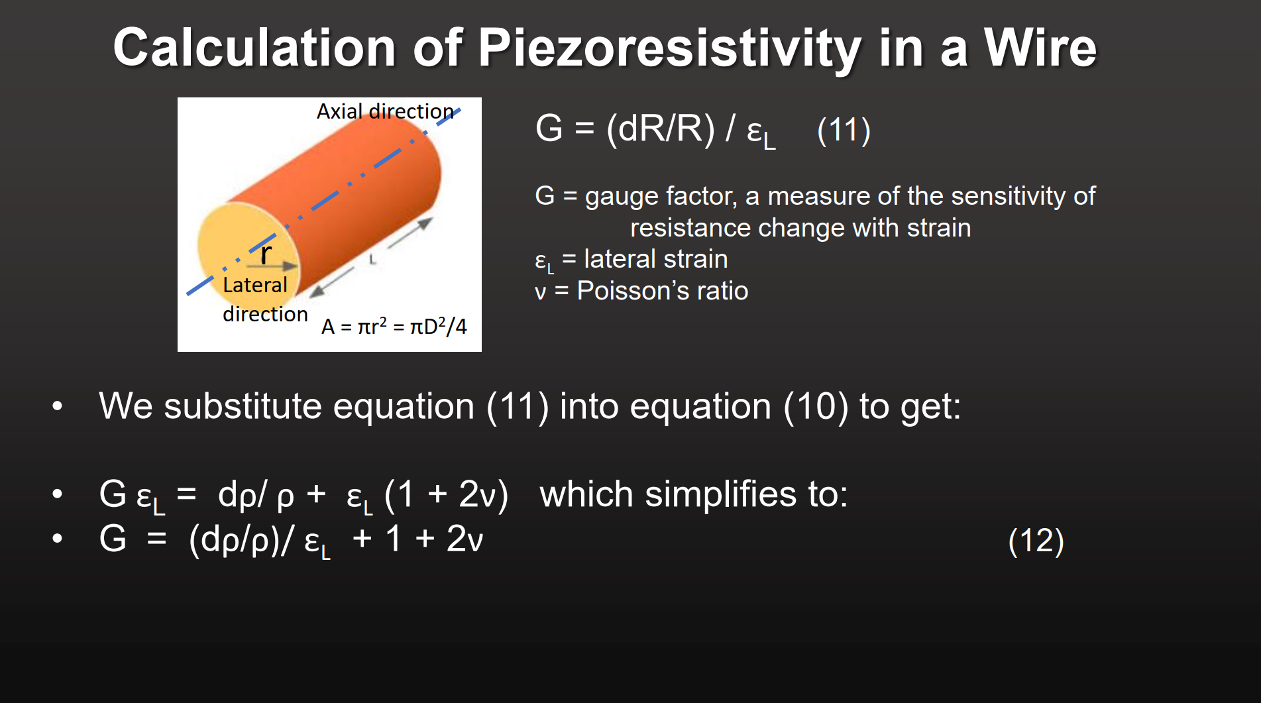

1. A circuit for piezoresistive pressure sensor is arranged so that resistors R2 and R3 see tensile stress, resistors R1 and R4 see compressive stress, and the excitation voltage Vi of 5 volts is applied across the intersection of R1 and R3 and that of R2 and R4. When pressure is applied R1 = 993 ohms, R2 =1007 ohms, R3 = 1007 ohms, and R4 = 993 ohms. What is the output voltage Vo in volts? Type in a 3-place decimal.

Answer: **0.035V**

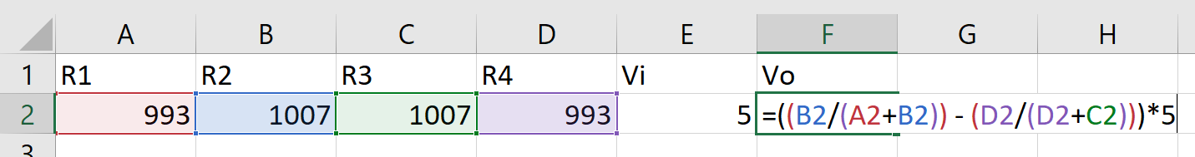

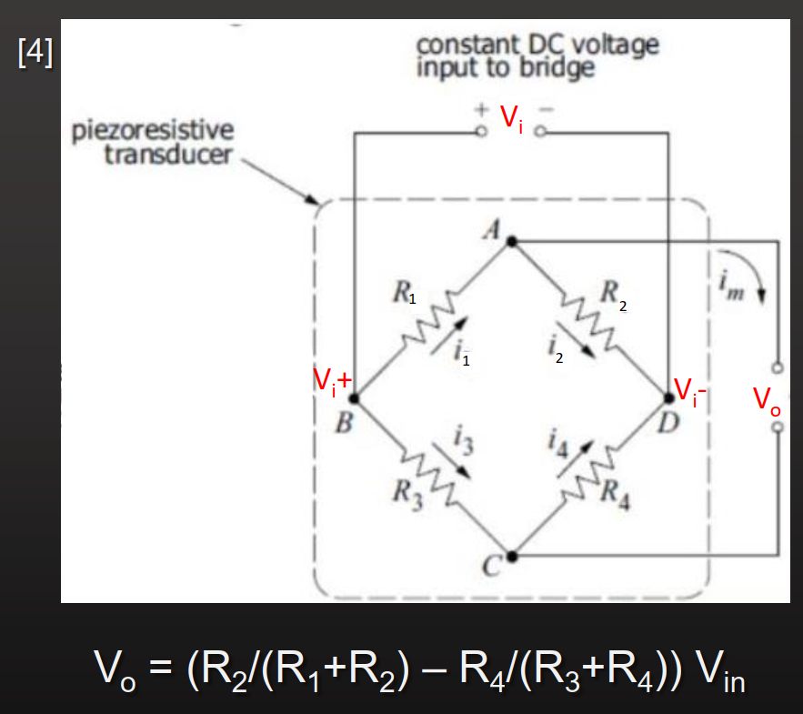

1. A pressure sensor at the bottom of a large tank of ethanol is used to measure absolute pressure. (Don’t get excited – the ethanol (a.k.a. booze) is not for you.) The column of ethanol is 3 meters high. What is the absolute pressure at the bottom in kilopascals? Type in a 1-decimal number.

Answer: **124.5216kPa**

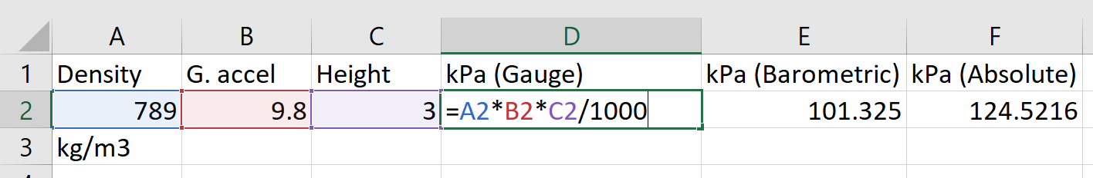

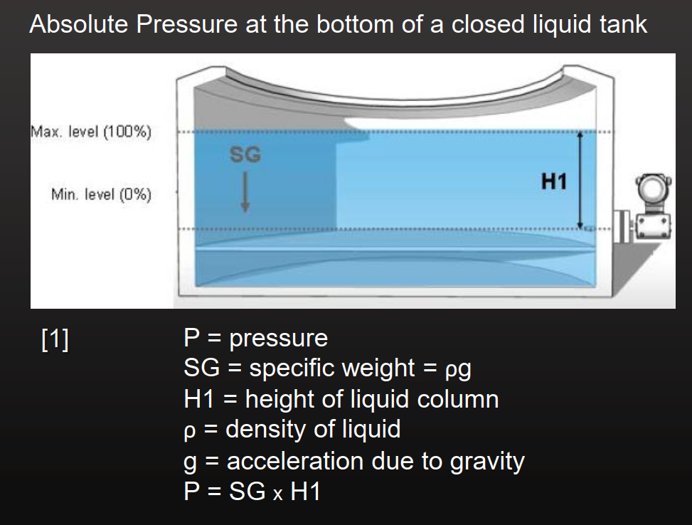

1. The sensitivity of a constant voltage strain gauge bridge circuit is defined as the ratio of the change of signal voltage to excitation voltage for some fixed strain change. The Wheatstone bridge circuit for 4 piezoresistive sensors is shown in the screenshot below, taken from one of our slide decks.

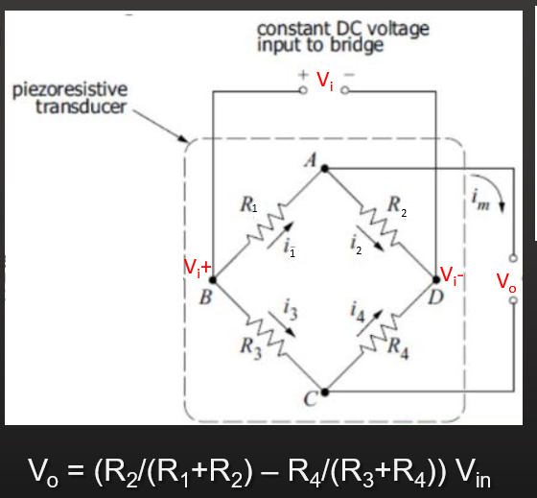

Use the formula shown to algebraically derive the formula for the sensitivity of the bridge: ΔVo / Vi = εG, when R = R1 = R2 = R3 = R4.

Answer:

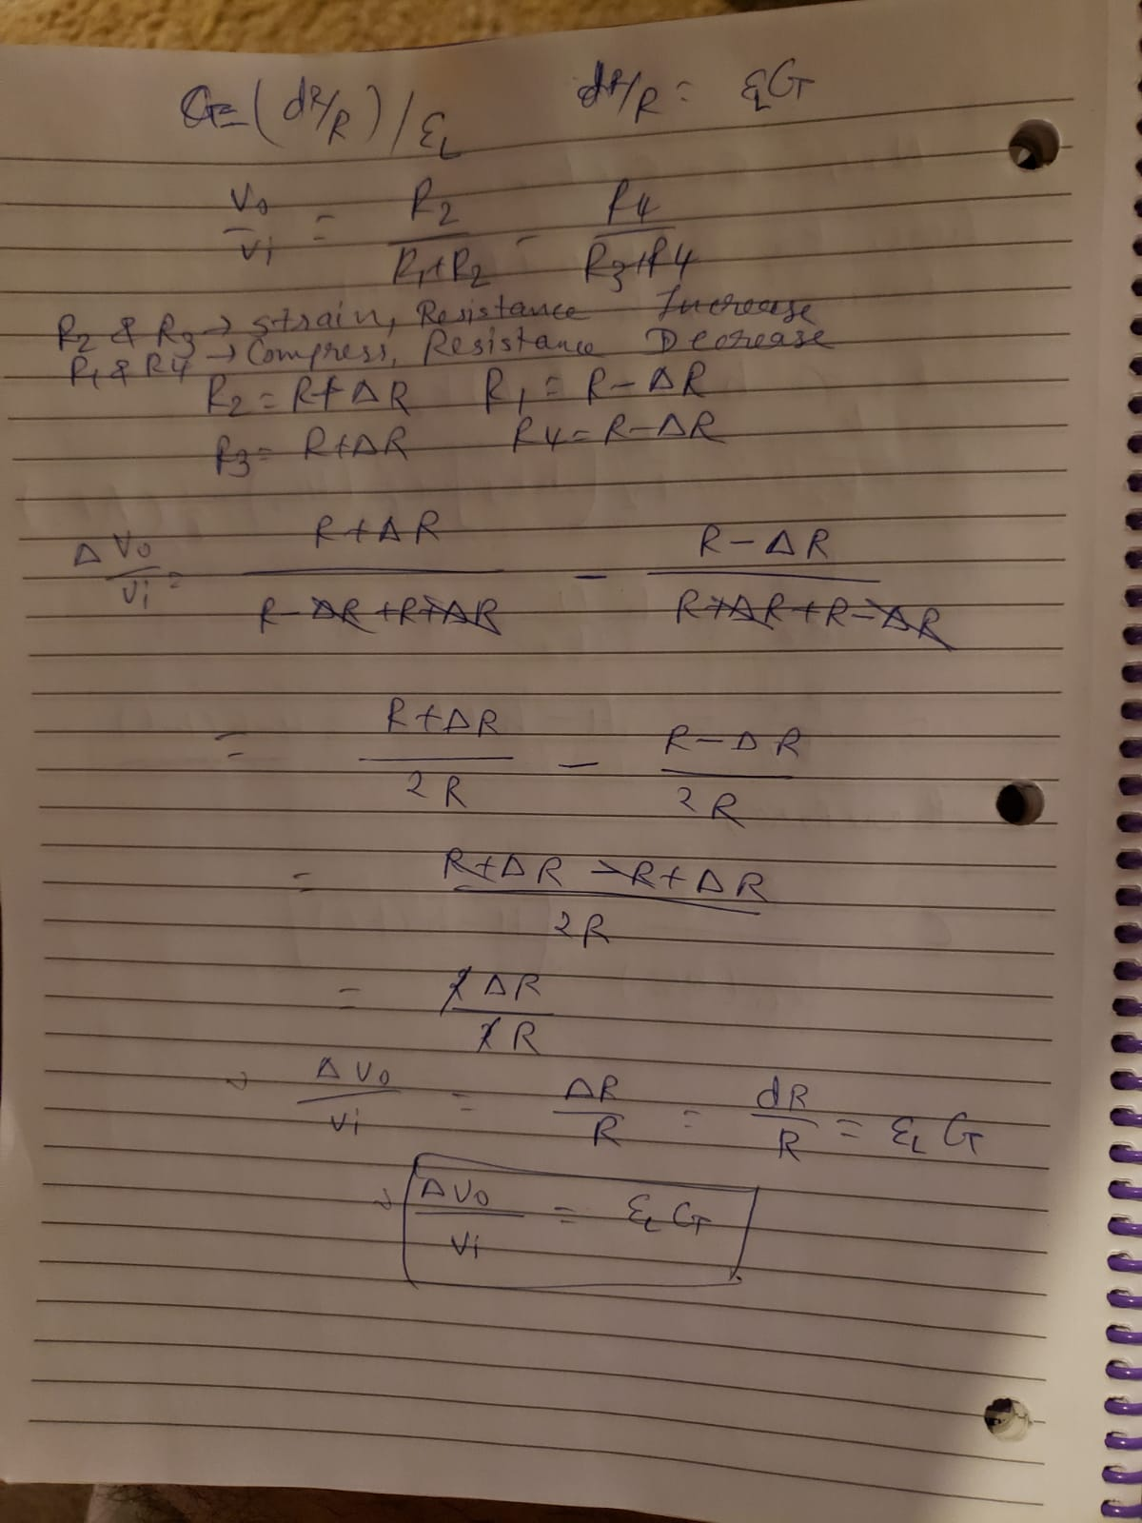

1. Derive the expression for capacitance in a cylindrical capacitor, as shown in this screen shot from one of our slides.

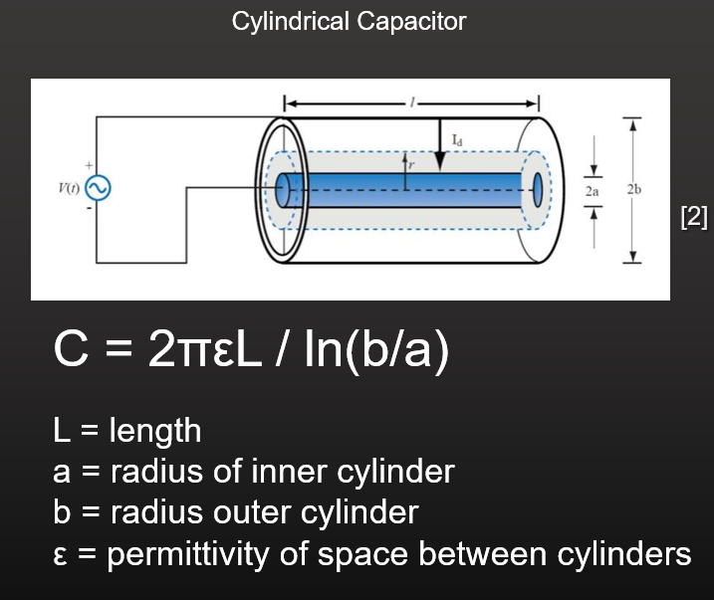

Answer:



1. Derive the formula for the capacitance of the capacitive level sensor, as shown in this slide from one of our slide decks:

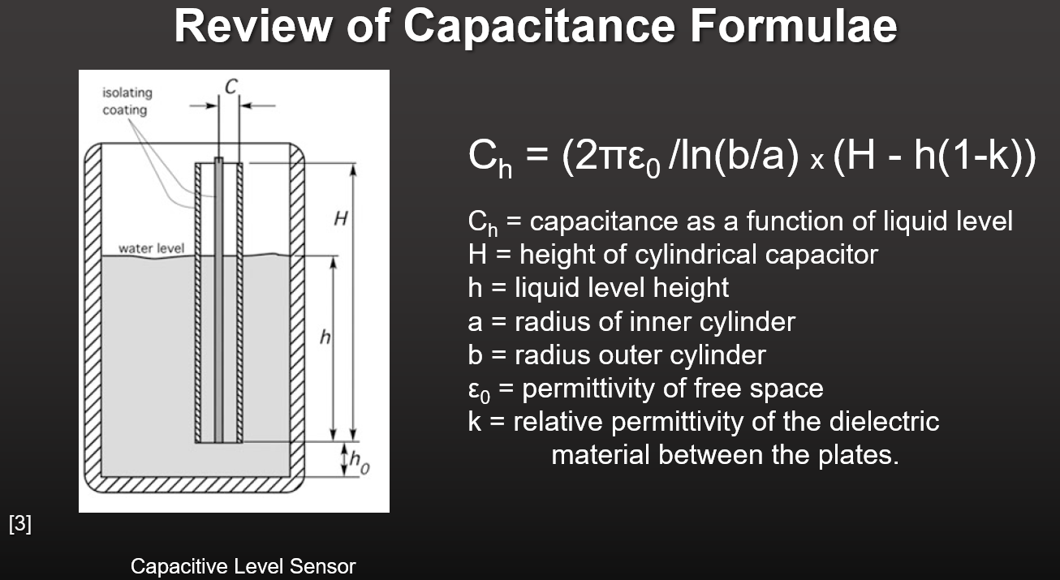

Answer: Reference: [**[7]**](http://www.ti.com/lit/ug/tidu736a/tidu736a.pdf)



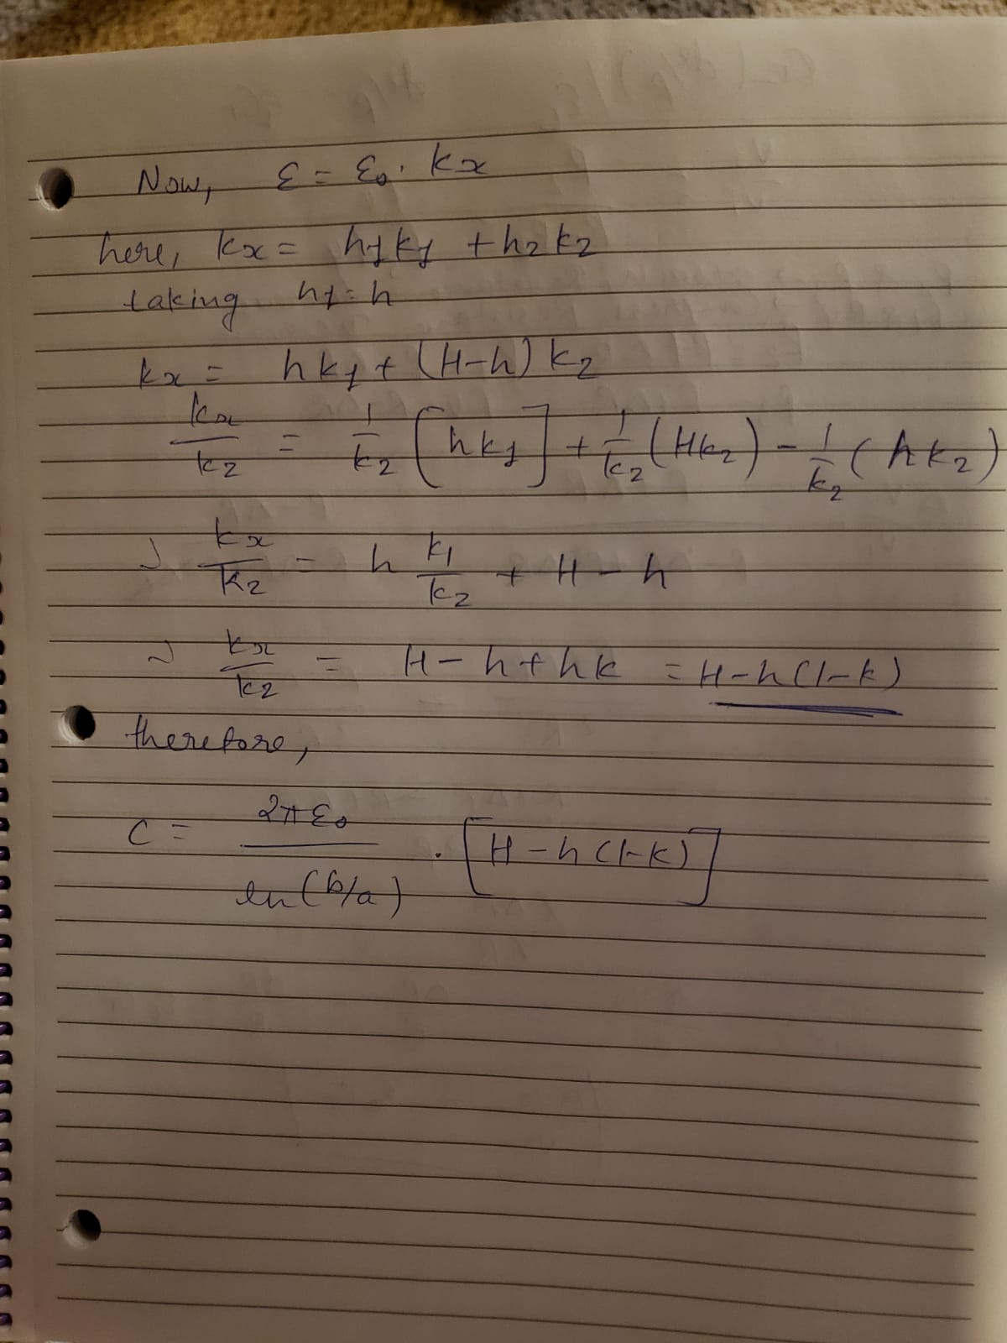

1. What is the capacitance in pF of a capacitive level sensor immersed in pure water with these attributes? (Type in a one decimal number)



Answer: **5.35pF** [**[8]**](http://coldregionsresearch.tpub.com/SR98_02/SR98_020009.htm)

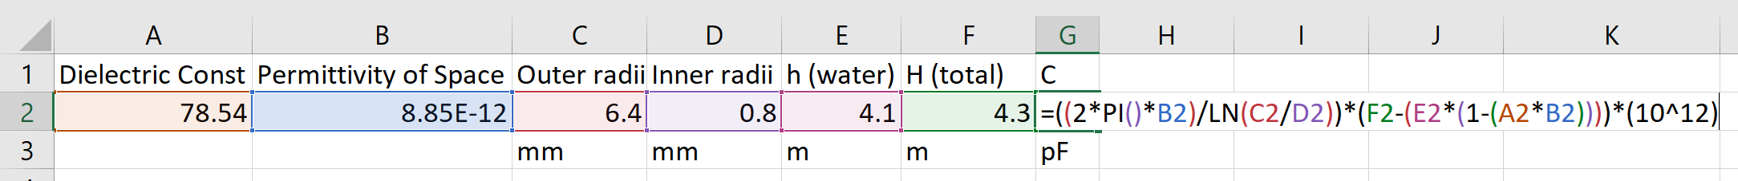

1. Go to Google Patents ([www.patents.google.com](http://www.patents.google.com)) and download US patent 6,647,794. Read the patent and answer the following questions:

Q.1 Why is an accurate absolute pressure sensor needed for the gage pressure sensor in this patent?

Answer: In gage transmitters that electronically calculate a pressure difference based on two absolute pressure sensor outputs, accuracy and repeatability of the sensors are particularly important **to avoid introducing errors in the Subtraction process.**

Q.2 In figure 1 what are the functions of elements 110, 122, 121, 116, and 126.

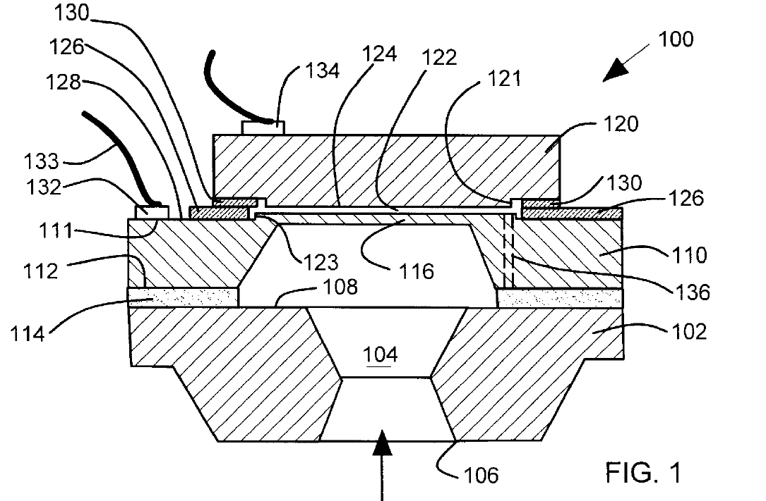

Answer:

Element 110 – A sensor layer: The pressure sensor includes a **sensor layer 110** having a first face bonded by an insulating bond to the mounting face. The sensor layer 110 includes a conductive diaphragm 116 that is aligned with the passageway to receive pressure.

Element 116 – A conductive diaphragm: **The conductive diaphragm 116 serves as a first capacitor electrode or plate**. The spacing between the capacitor plates varies as the diaphragm 116 is deflected by pressure.

Element 122 – A reference vacuum cavity: The reference layer includes a **conducting surface facing the conductive diaphragm across the reference vacuum cavity 122 to form a pressure sensing capacitor**.

Element 121 – The mesa height: **The mesa 121 has a height that is selected to provide the desired spacing between capacitor plates in the vacuum cavity 122**. The height of mesa 121 can be selected to correct for the thickness of bonding layers.

Element 126 – First insulating layer: **The sensor layer 110 further includes a first insulating layer 126 surrounding the conducting diaphragm 116 on a second face 128**. The reference layer 120 includes a second insulating layer 130 bonded to the first insulating layer 126. In one preferred arrangement, the reference layer 120 and the sensor layer 110 comprise silicon and the first and second insulating layers 126, 130 comprise grown Silicon dioxide and are fusion bonded together.

Q.3 Figure 2 describes a method of electrical connections, which should be familiar to you. We discussed in during the lectures on capacitive pressure sensors. What is it, and how does it work in this patent?

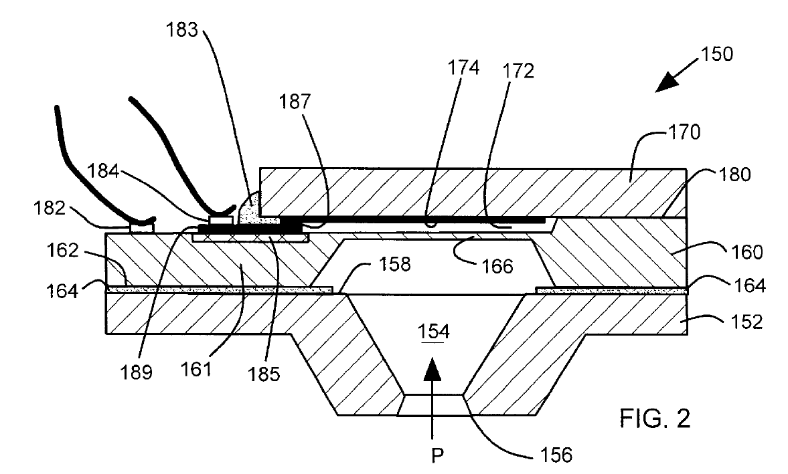

Capacitive Pressure Sensor: Capacitive pressure sensors typically use a thin diaphragm as one plate of a capacitor. Applied pressure causes the diaphragm to deflect and the capacitance to change. This change may or may not be linear and is typically on the order of several picofarads out of a total capacitance of 50-100pF. The change in capacitance may be used to control the frequency of an oscillator or to vary the coupling of an AC signal through a network. The electronics for signal conditioning should be located close to the sensing element to prevent errors due to stray capacitance [**[9]**](https://www.sensorsmag.com/components/fundamentals-pressure-sensor-technology) .

In this patent, the construction of the capacitive sensor is described in Figure 1, and works as per the following:

The conductive diaphragm 116 serves as a first capacitor electrode or plate. The conducting surface 124 serves as a second capacitor electrode or plate. The vacuum cavity 122 provides a spacing between the generally parallel capacitor plates. The spacing between the capacitor plates varies as the diaphragm 116 is deflected by pressure P. The insulating bond 114 provides electrical insulation from the base layer 102 and preferably comprises a layer of glass frit.

The electrical connections are as following:

The first electrical bonding pad 184 is deposited on electrical conductor layer 189 that connects to the conducting surface 174 which forms a second plate or electrode of the pressure Sensing capacitor. The first electrical bonding pad 184 and electrical conductor layer 189 are disposed on an isolation channel 185 on the sensor layer 160. The electrical conductor layer 189 is in electrical contact with the conducting surface 174 by way of a metal bridge 18. A Second electrical bonding pad 182 is disposed on the sensor layer 160 and thus connects to the conducting diaphragm 166 which forms one plate or electrode of the pressure Sensing capacitor. The Second electrical bonding pad 182 is in electrical contact with the sensor layer 160.

Q.4 What error condition is represented in figure 4?

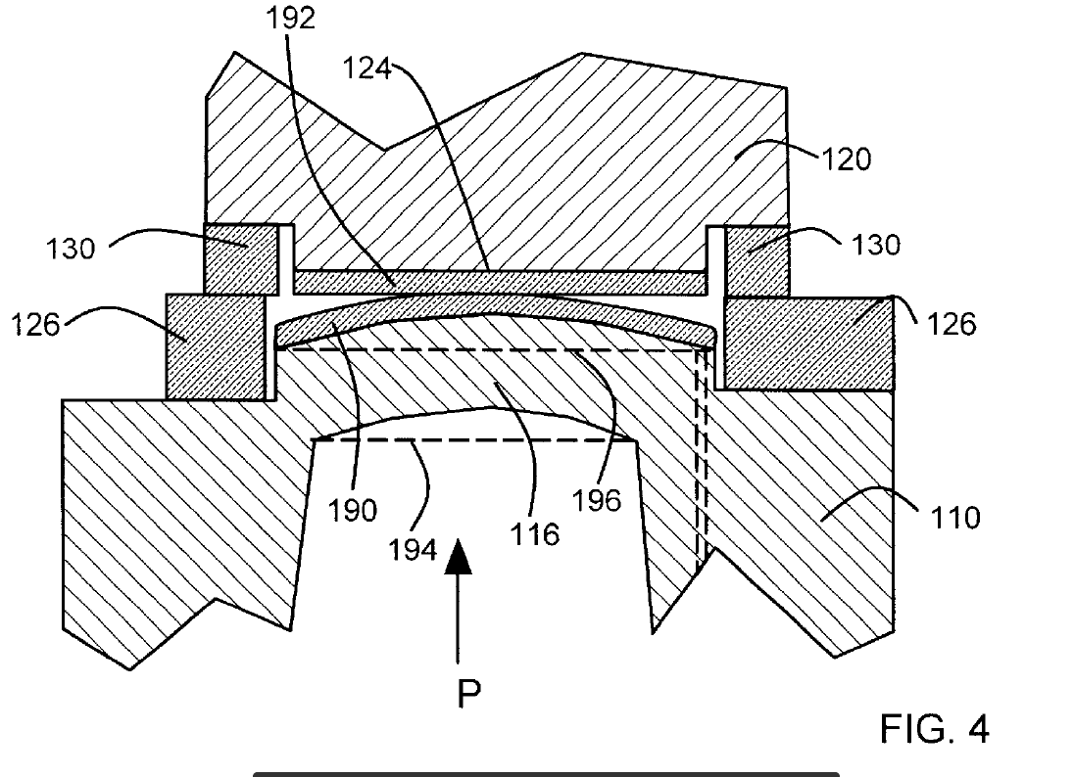

Answer: Figure 4 is the illustration of the conductive diaphragms 116 during **overpressure conditions**. An overpressure condition is a condition where **the pressure P exceeds the nominal measurement range of the pressure sensor**. Under overpressure conditions the conductive diaphragm 116 deflects away from its nominal flat shape (illustrated by dashed lines 194, 196) and rests against and is supported by the conducting Surface 124 of reference layer 120.

Q.5 What is illustrated in figures 6 through 9?

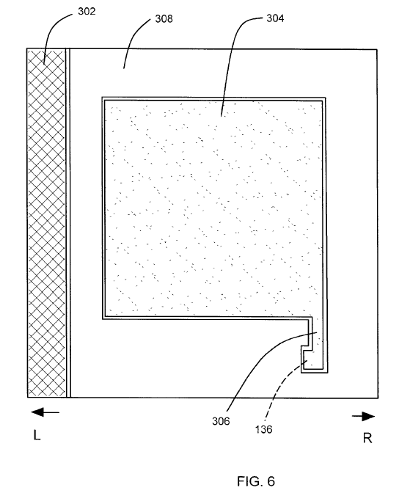

Answer: **Figures 6-9 illustrate various masks that are used in manufacturing of the sensor** 200 illustrated in figure 5. References L (left) and R (right) are included in figure 5 to identify left and right sides of the sensor 200. Corresponding references L and R are included in figures 6-9 to indicate the orientation of the various masks relative to sensor 200 in figure 5. The masks illustrated in figures 6-9 **provide additional details on the shapes of various features** shown in figure 5. The masks in figures 6-9 are illustrative for manufacture of one sensor. It will be understood by those skilled in the art that a sensor can be batch fabricated with many other sensors on wafers and then diced. **In the case of batch fabrication, the individual masks illustrated in figures 6-9 are typically repeated in regular arrays on masks large enough to complete entire wafers**.

Q.6 What does the converter circuit do in Figure 11?

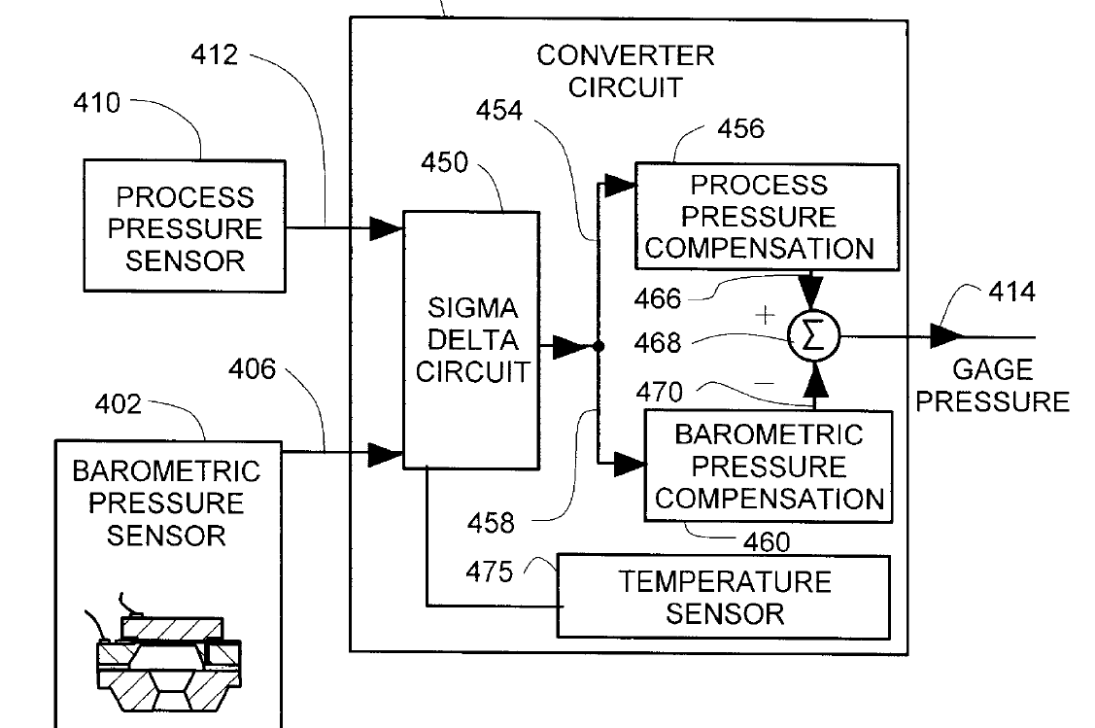

Answer: The **primary function of the converter circuit is to take inputs in the form of uncompensated process pressure and barometric pressure (raw readings from sensor), process them – compensate them – and finally give the accurate gage pressure as the output**. Following is the details on functionality:

Figure 11 illustrates an exemplary block diagram of the gage pressure transmitter 400 in figure 10. The process pressure sensor 410 is coupled along leads 412 to a sigma delta circuit 450 in a converter circuit 452. The barometric pressure sensor 402 is coupled along leads 406 to the sigma delta circuit 450 in the converter circuit 452. The sigma delta circuit 450 provides a digital signal representative of uncompensated process pressure along line 454 to a process pressure compensation circuit 456. The sigma delta circuit 450 provides a digital signal representative of uncompensated barometric pressure along line 458 to a barometric pressure compensation circuit 460. The process pressure compensation circuit 456 provides an output rep resenting compensated process pressure on line 466 to a difference calculating circuit 468. The barometric pressure compensation circuit 460 provides an output representing compensated barometric pressure on line 470 to the difference calculating circuit 468. The difference calculating circuit 468 calculates a difference between compensated

process pressure and compensated barometric pressure, which is an accurate indication of gage pressure 414. The compensation performed by circuits 456, 460 includes gain and linearity corrections.

1. A pressure transmitter has the following specifications:



What is the total error budget in MPa? (Type in a three-place decimal.)

Answer: **±0.0463MPa (rms value)**

